**UNVEILING MARKETING INSEIGHT**

INTRODDUCTION

# 1.OVERVIEW

# The main objective of this project is to analyse the customers spending behaviour and and identify opportunities for the growth by leveraging data analytics and data driven decision making

# The data talks about sale of milk, groceries, frozen items , delicassens, detergent papers of three regions in two channels

# Wholesale or distributing is a sale of good to retailed to industrial commercial institutional or other professional businessman to other wholesalers business and related subordinate services

### 2.PURPOSE

# The primary purpose of this project is to understand customers spending patterns preference to under trends across various dimensions by conducting a comprehensive analysis business can optimise their marketing strategies improve product offerings and enhance customer engagement to drive revenue growth.

PROBLEM DEFINITION &DESIGN THINKING

### EMPATHY MAP

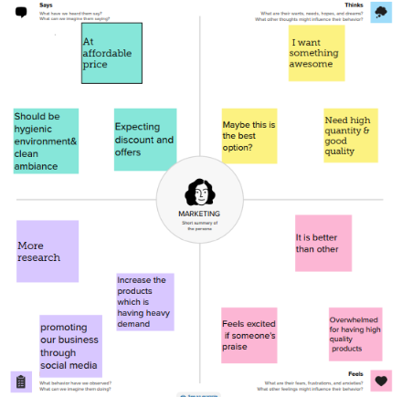

### IDEATION AND BRAINSTORMING MAP

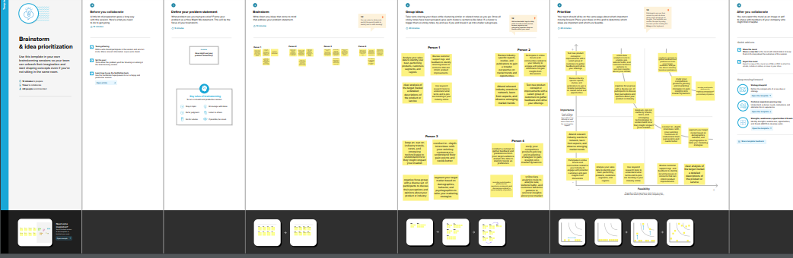

RESULT

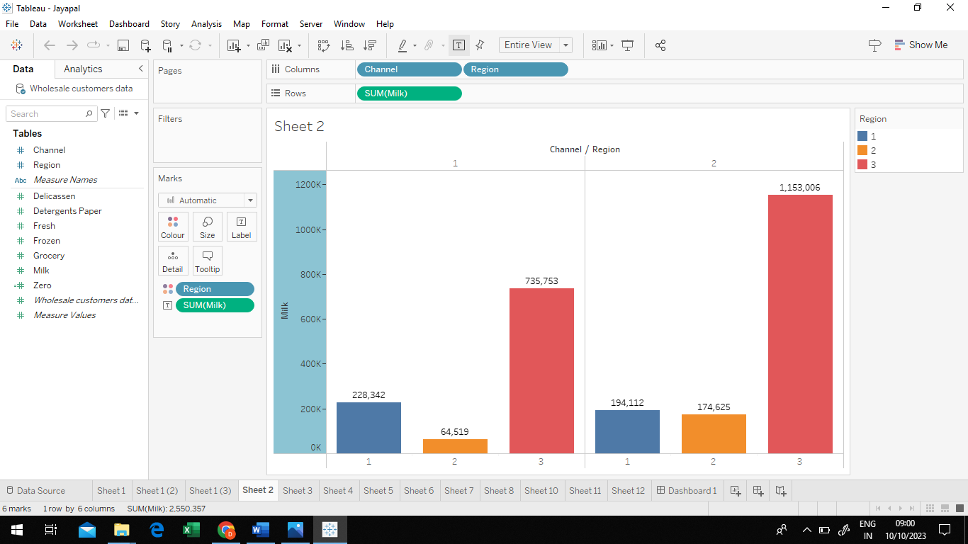

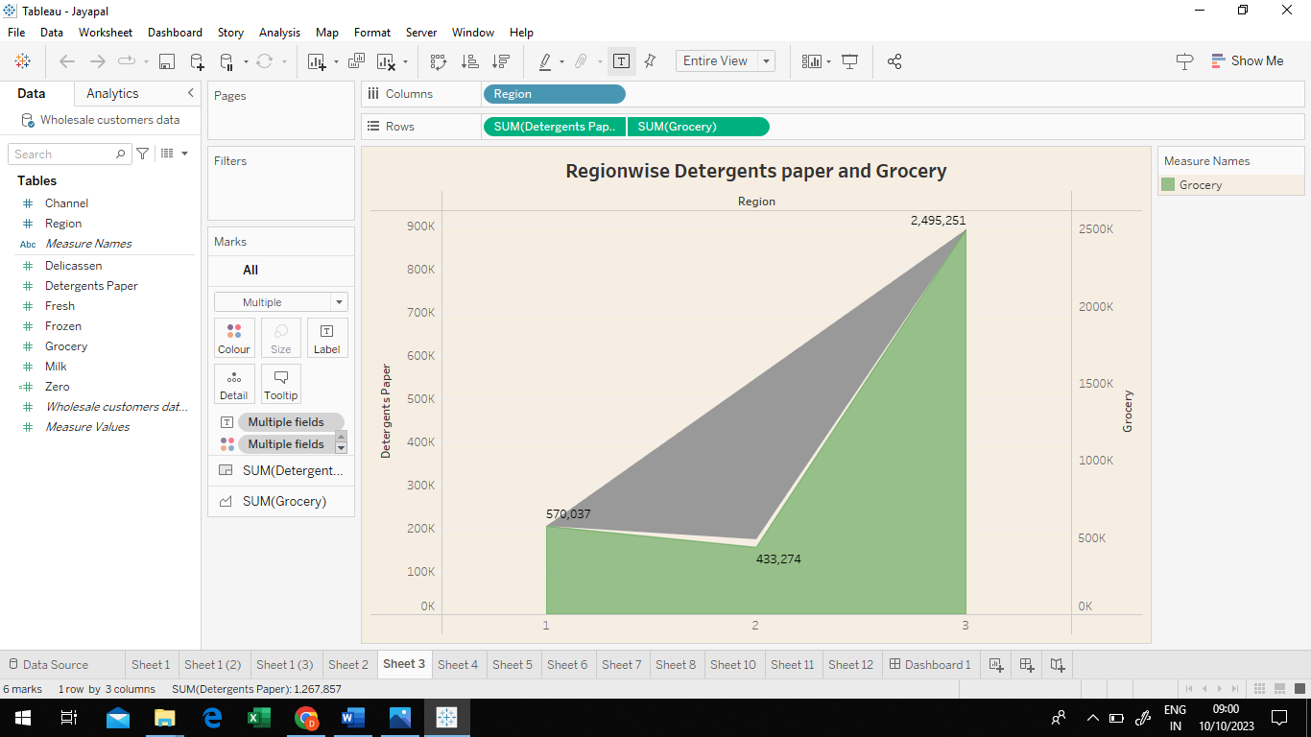

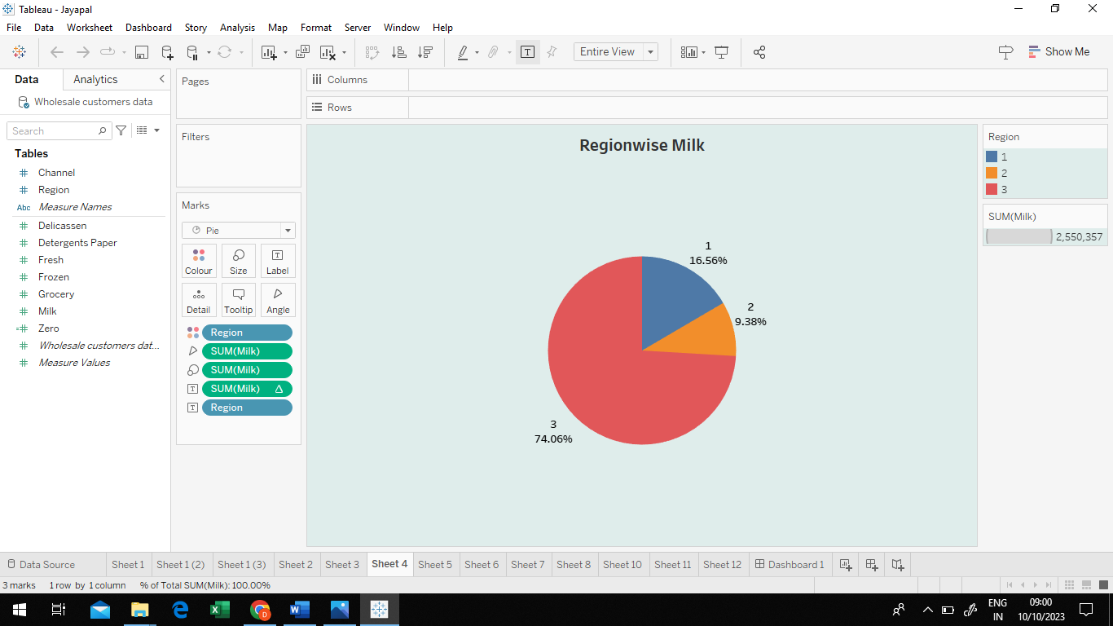

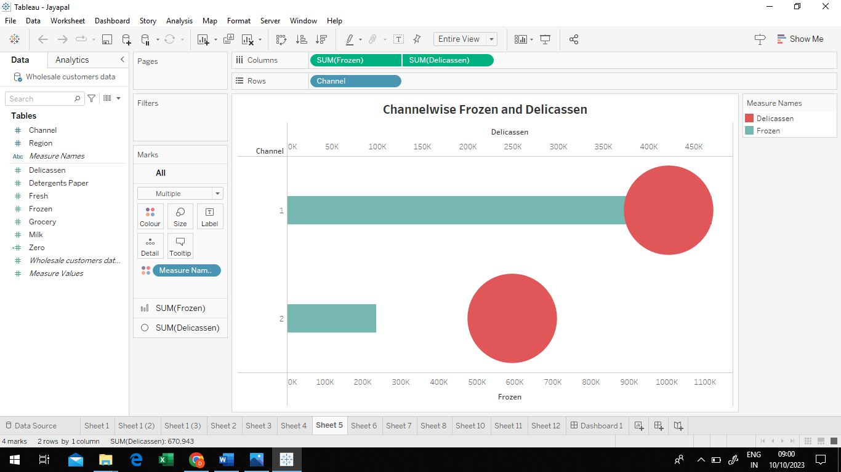

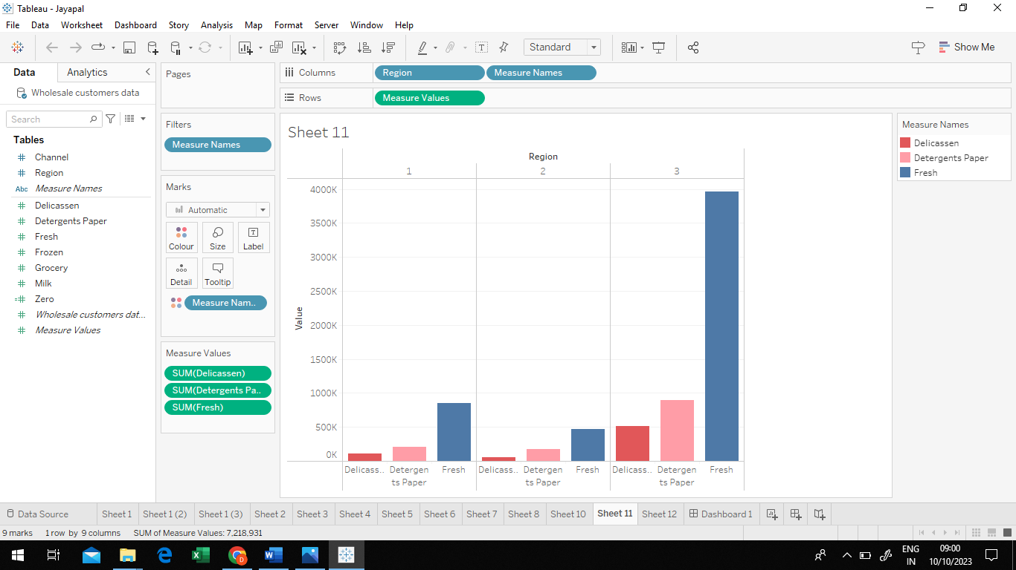

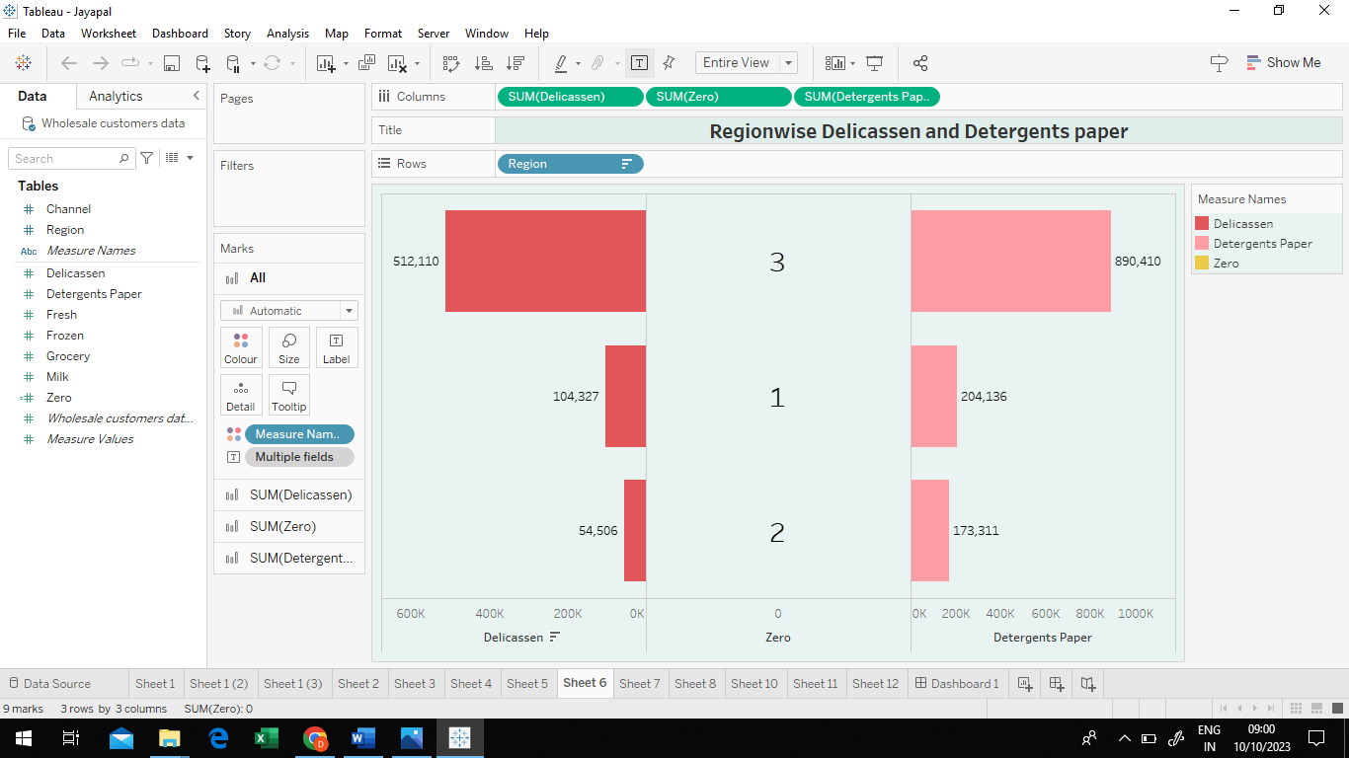

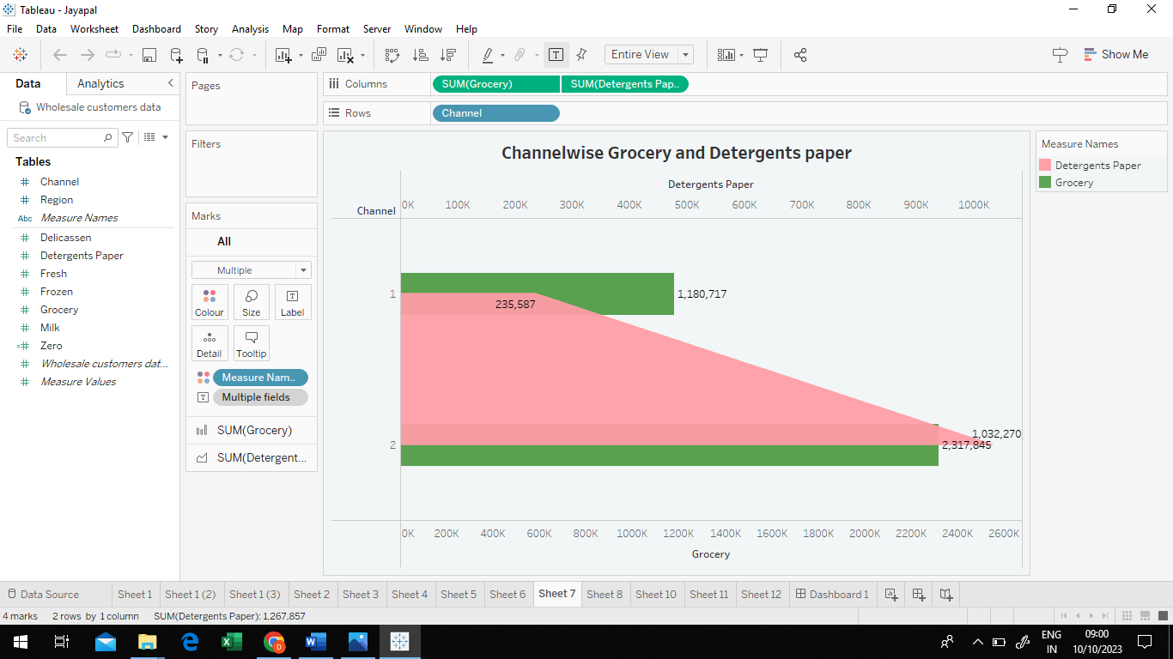

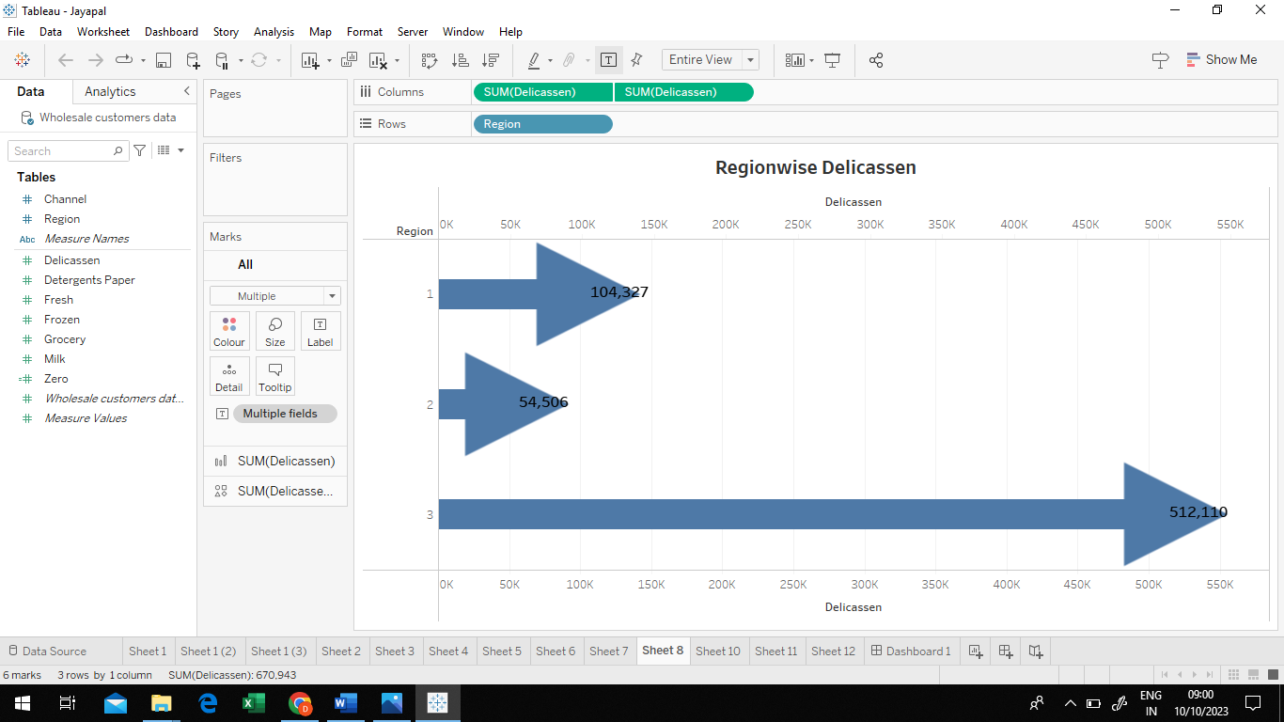

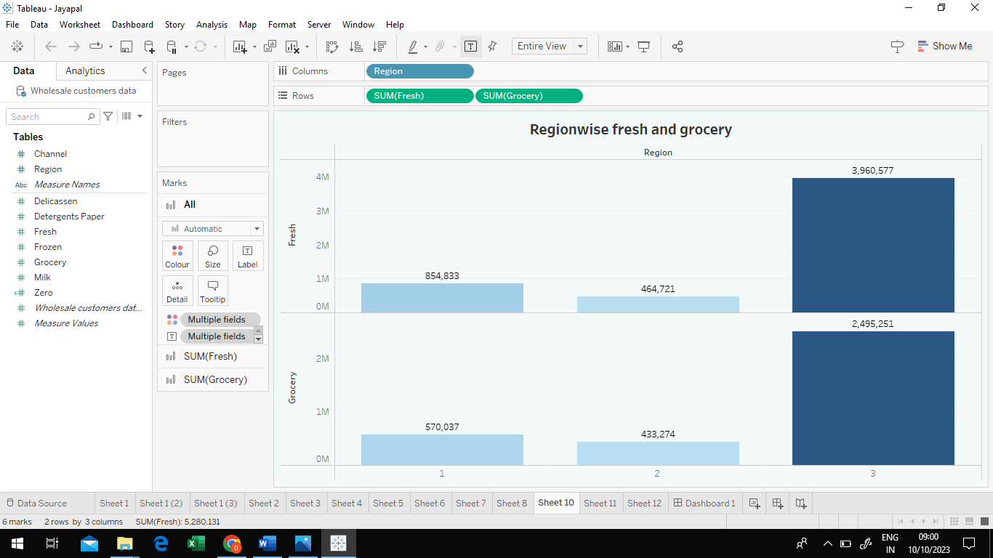

ADVANTAGES AND DISVANTAGES

# ADVANTAGES

# The biggest advantage of the marketing analytics is that business that is allows us to make a more scientific approach to the market . It means that we can measure our effectiveness of our compaigns and then use the data to the make smarter decision about how to spend the money

# DISADVANTAGES

# The disadvantage of the marketing insight is that When a company relies too much on marketing information system , it might miss important marketing trends. An Marketing inseight requires constant data updating for accurate monitoring and reporting, making past data useless. The quality of reports and marketing information depends on the quality of data stored in Marketing inseight.

APPLICATION

# Marketing insights benefit both parties by meeting your target audience's needs and wants while also profiting. This is especially true when marketing a previously unused or unknown innovation. In other words, the best market insights help those selling the invention and the companies needing it.

CONCLUSION

By analysing the data we can define trends of product sale in the three regions of two channels.But the data provided is not sufficent to analyse it deeply.if the given data represent variety of brand in these product that can help us to which of the brand products are highly consumed by the consumers.By this we can analyis the consumers demand.

FUTURE SCOPE

# The future scope of marketing is increasing exponentially. It involves researching, planning, and coordinating. The growth of digital technologies and the Internet boom have positively impacted marketing scope